PROGRAM 9

/\* Program to demonstrate while loop \*/

#include<stdio.h>

int main()

{

int i=1;

while(i<=5)

{

printf("%d\n", i);

++i;

}

return 0;

}

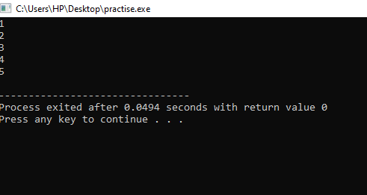

/\* Program to demonstrate do while loop \*/

#include<stdio.h>

int main()

{

double number, sum=0;

do

{

printf("Enter a number:");

scanf("%lf", &number);

sum+=number;

}

while(number !=0.0);

printf("Sum=%.2lf", sum);

return 0;

}

